Awareness-cum-Training Workshop on "Emergency Planning, Preparedness & Response" at Mandideep, Dist. Raisen on 25/01/2012

A one day workshop on the Emergency Planning, Preparedness & Response was organized at Mandideep Industrial Area of Raisen District near Bhopal, the capital city of Madhya Pradesh. A total of 68 participants from various industries, transporters of Hazardous chemicals, the first responders and the regulators (MPPCB and DIHS) attended the programme and were benefited from the workshop.

After the welcome address by Mr. K. Vaidyanathan, Chief Operating officer of M/s Hindustan Electrographite Graphite Ltd., the programme was inaugurated by Dr. N.P. Shukla , the Chairman, M.P. Pollution Control Board and Shri TEC Vidyasagar, followed by opening remarks by Dr. Gunwant Joshi, Chief Chemist and Head of Emergency Response Centre who explained the need of organizing such a program and highlighted the importance of preparedness in the chemical emergencies. The chief guest of the program Dr. N.P. Shukla praised the efforts of the ERC in taking the issues of chemical safety and preparedness to it’s member industries and the first responders. Shri K. Vaidyanathan, highly appreciated the activity taken-up by ERC and stressed the need of having such awareness programs at all the industrial locations so that the concept of training regarding the Emergency Preparedness for the Chemicals/Industrial hazards is passed on to the Industries and whenever such emergency situations arise they are tackled squarely and effectively. The vote of thanks was given by shri Alok Singhai, Regional Officer, MPPCB, Bhopal who briefly outlined the scheduled activities of the day.

The Technical program started with a lecture from Dr Asit K. Patra, Assistant Director, Disaster Management Institute, Bhopal who spoke about the Technical, Legislative & Planning issues involved in the Emergency Management:. His lecture was followed by the power point presentation by Shri TEC Vidyasagar, Ex. Dy. Chief Inspector of Factories, Govt of Andhra Pradesh where with the help of photographs and examples of Industrial accident cases he highlighted various issues pertaining to the Consequence & Risk analysis in making and updating the On-site Emergency Management Plans in the Industries.

The main attractions of the day were the Table–Top exercise and the Mock drill demonstration. Table–Top exercise provides an opportunity to the Industries to test their ability to respond to hazardous materials (Haz-Mat) incidents. The exercise also provides the opportunity to identify the response and coordination issues that could arise at the time of emergency situations and help validate coordination and communications capabilities for Haz-Mat incidents. The exercise was also aimed to assess the strength and weaknesses of the emergency management plan.

The Table top exercise was a new concept to many of the participants and was conducted with the help of eight volunteers from amongst the participants who were assigned different roles such as the Incident Controller , Assistant Incident Controller, Communication Officer, Fire and safety set-up in-charge, Medical Officer etc. After fixing a scenario (Fire incidence in this case), a preliminary briefing of the volunteers was held to finalize the emergency response action plan. The actual exercise involved the conducted role-play of response communication and the follow-up action demonstrated by all the volunteers. The observers and the remaining participants were requested to observe the act closely, scrutinize the communication & action and comment on the various issues involved depending on their perception of the situation.

The table top exercise was followed by the field demonstration of mock-exercise to give a practical exposure to the trainee participants. The scenario was the fire near the furnace oil storage area of the Industry. The mock-drill demonstration was guided by Shri M.M. Dammani (Vice President) Technical, M/s. HEG Limited and organised by the officers & staff of Safety and Environment Department of the same industry. A video-shoot was also taken to record and have a closer look at both the mock-drill events and also to analyze various components minutely later for further improvement.

After the Table-Top exercise and the Mock drill demonstration it was a time for the debriefing exercise. The de-briefing & review was done by Shri TEC Vidyasagar, Shri Arvind Sharma, Astt. Director & Shri Ajay Nema, Joint Director, Department of Industrial Health and Safety, Government of Madhya Pradesh along with the participants who were independent observers of the communication that took place amongst the key personnel during the emergency situation as the event unfolds and also the actions that followed during the mock-drill.

In the last session, there was a presentation by Dr. Gunwant Joshi regarding the Emergencies and the role of Emergency Response Centre where he traced the inception and the functions of the ERC. He also briefed about various types of the database and other technical capabilities maintained by the ERC and also explained how it can be helpful to the Industries in the event of emergency sighting the examples of past technical support rendered by ERC at different occasions. His lecture was followed by a brief film highlighting the importance of the proper communication in effective emergency response to any Industrial Accident situation.

Dr. Rajendra Chaturvedi, Scientist, along with Shri Manoj Jain, Chemist, ERC, helped build up the background material which was distributed in the form of C.D. as part of course material. The programme was concluded with the distribution of the Certificates of Participation to the participants and ended with thanks to the Chair, dignitaries and the participants on behalf of ERC and Pollution Control Board by Dr. Gunwant Joshi, Head, Emergency Response Centre.

Schedule

9.30 - 10.00 hrs. | REGISTRATION
10.00 AM - 10.50 AM | Inaugural Session
10.00 AM - 10.50 AM | Welcome address | Shri K Vaidyanathan,Chief Operating Officer  M/s H.E.G. Limited, Mandideep
10.00 AM - 10.50 AM | Opening Remarks | Dr. Gunwant Joshi, Chief Chemist, ERC, Bhopal
10.00 AM - 10.50 AM | Address from Guest of honour | Shri TEC Vidyasagar, former Dy Chief Inspector of factories, Government of Andhra Pradesh
10.00 AM - 10.50 AM | Address by Chief Guest | Dr. N.P. Shukla, Chairman  M. P. Pollution Control Board, Bhopal.
10.00 AM - 10.50 AM | Vote of Thanks | Shri Alok Singhai, Regional Officer,  M.P. Pollution Control Board, Bhopal
10.50 AM - 11.15 AM | …………………… High Tea ………………..
11.15 AM- 12.15 PM  12.15 PM- 01. 45 PM | Technical Session I & Discussion  1. Emergency Management: Technical, Legislative & Planning Perspectives  By Dr. Asit K. Patra, Assistant Director, DMI  2. "Consequence & Risk analysis in On-site Emergency Management Plan”  by Shri TEC Vidyasagar, Ex.- Dy. Chief Inspector of Factories, Govt of A.P.
01.45 PM - 02.15 PM | ………………… Lunch Break …………………
02.15 PM - 03.00 PM  03.00 PM - 03.30 PM | Technical Session II & Discussion  1. “Table Top Exercise of Mock-drill for Emergency Response "  (GROUP ACTIVITY) guided & supervised by shri TEC Vidyasagar &  Supported the officials of DIHS, Govt. of Madhya Pradesh.  - “ Field Demonstration of mock-drill”  by Safety & Environment Department , M/s. HEG Ltd., Mandideep
04.30 PM - 04.45 PM | …………………… Tea break ………………..
04.45PM - 05.30 PM | Closing Session  1. "Emergency Preparedness and Emergency Response Centre”  By Dr. Gunwant Joshi, Chief Chemist, ERC, Bhopal  2. Post Event Analysis & Review of the Mock-drill  by Shri Arvind Sharma, Astt. Director and Shri A.K. Nema, Joint. Director,  Directorate of Industrial Health & Safety(DIHS), Govt. of Madhya Pradesh.  3. Feedback and Discussion

Photographs

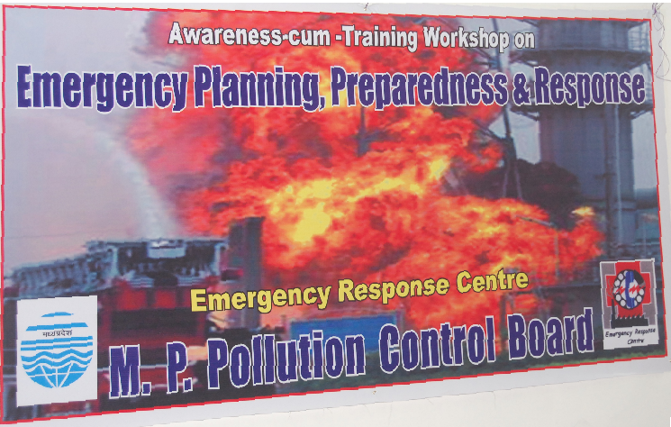

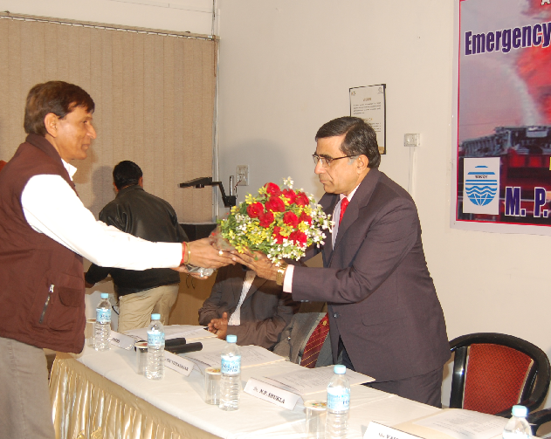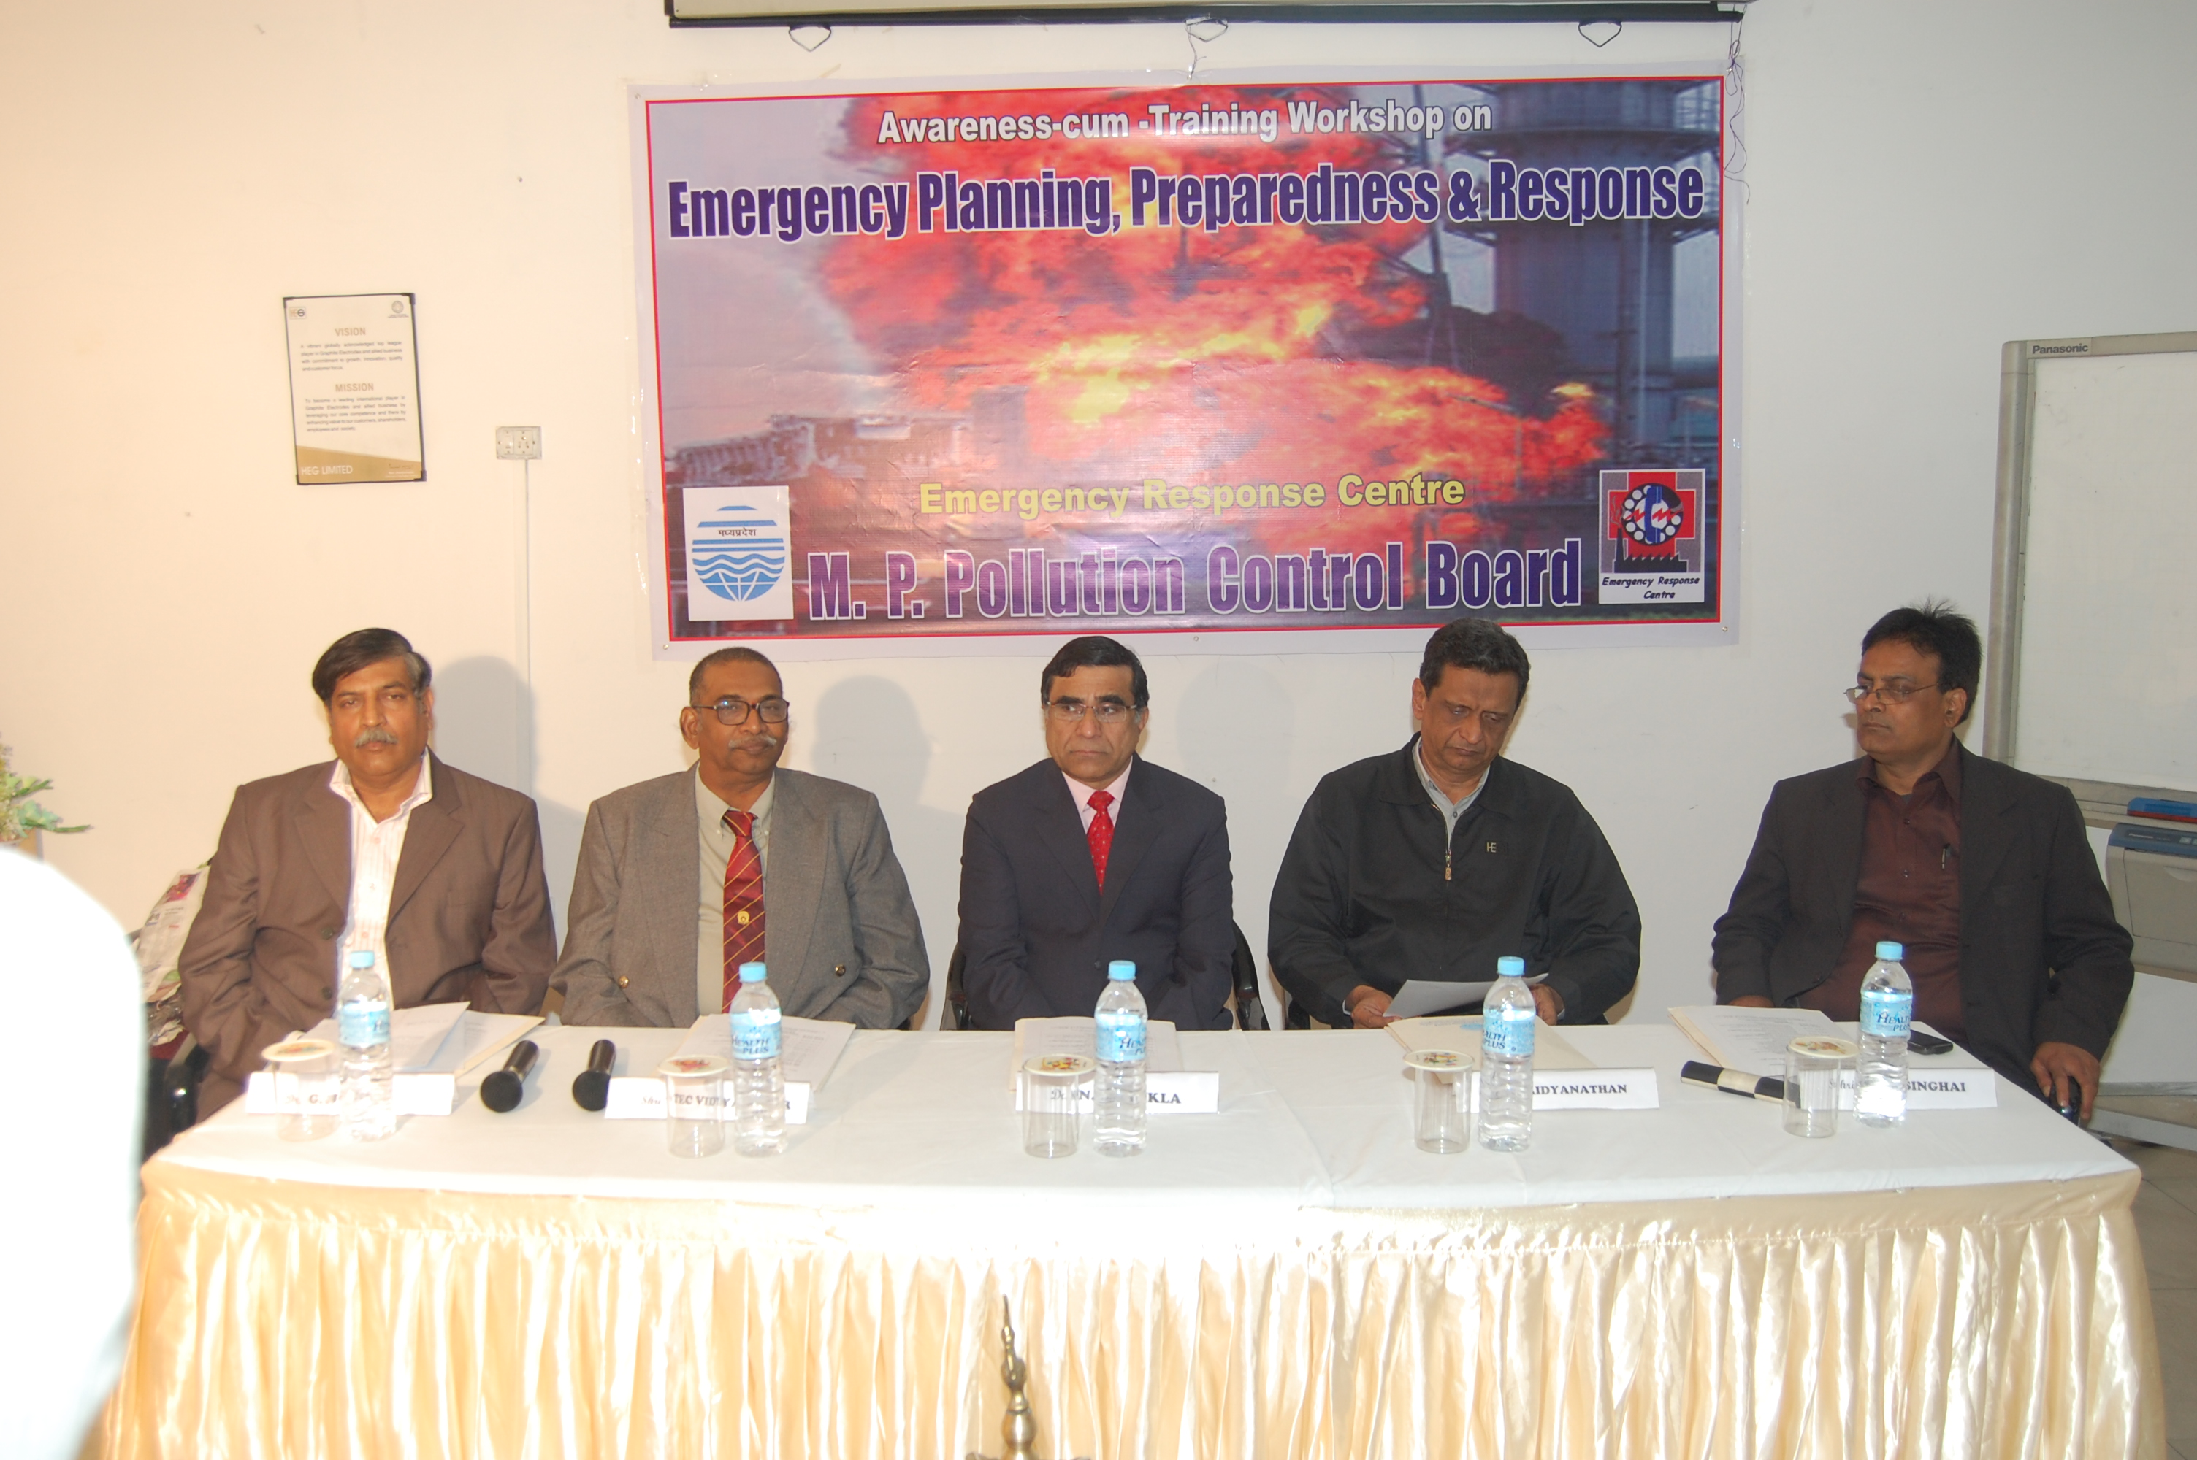

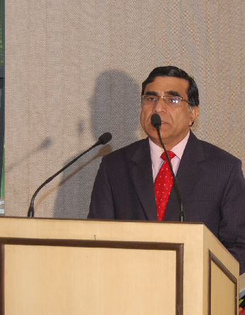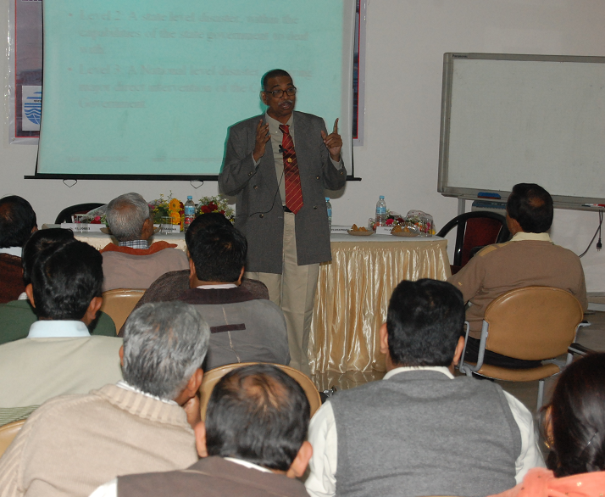

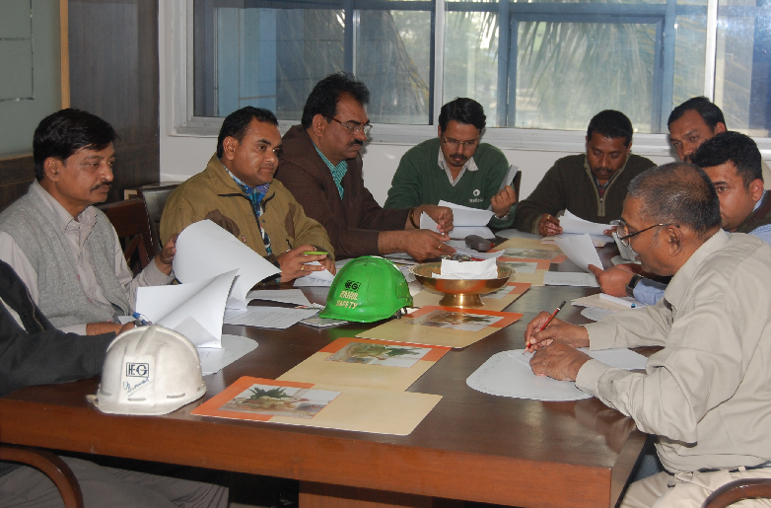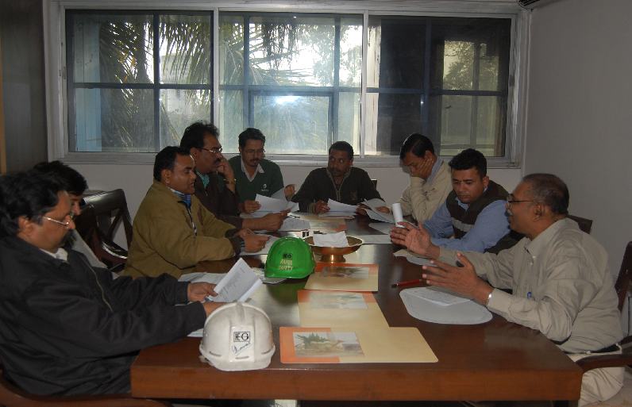
Shri TEC Vidysagar, Ex Chief Inspector of Factories, Govt. of AP
conducting briefing of Volunteers for the Table-Top exercise

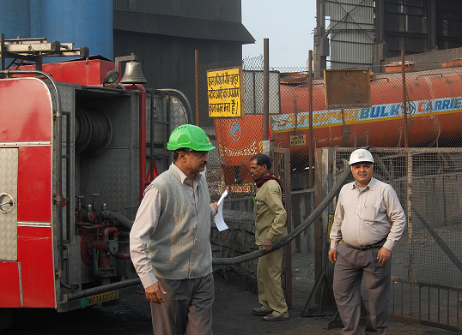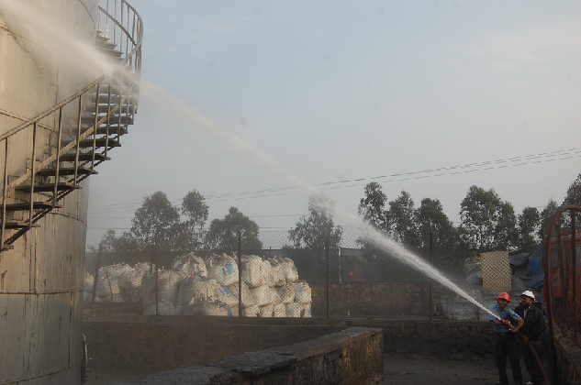
MOCK-DRILL at Furnace oil Storage tank of M/s. HEG Ltd.



