Awareness-cum Training Workshop on
Emergency Preparedness & Safe Management of Chlorine

Organized at Bhopal on 23/03/2013 by
Emergency Response Centre, M. P. Pollution Control Board

A Note on the proceedings of the Workshop

An awareness Workshop on "Emergency Preparedness & Safe Handling of Chlorine" was organized by Emergency Response Centre of M.P.Pollution Control Board, Bhopal at conference Hall of Palash Residency, Bhopal on 23rd March 2013 to create awareness on chlorine safety and emergency preparedness among the chlorine user industries and the water works personnel. The target group included the Municipal and Public Health Engineering officials engaged in treatment and supply of drinking water and also the First Responder Groups, such as, Officials from Fire brigade, Police, Medical Institutes & Health care facilities, and also the Officers from Local administration and the Regulators.

The program started with the welcome address by Dr. Gunwant Joshi, Chief Chemist, Emergency Response Centre, M.P. Pollution Control Board. Welcoming the guests and the participants, Dr Joshi briefly highlighted the issues related to the need of emergency preparedness and planning by industries in all the industrial areas in the State. He further expressed that such out-reach programs are being organized by ERC across the State in various industrial pockets with an idea to reach out to the industry in their own settings instead of calling them away from their work locations. This, he hoped, shall not only ensure presence of more and more participants but, shall help develop better coordination amongst the industry, the first responders, regulators and the technical support groups. Dr. Joshi, explained the need of organizing such a program and highlighted the importance of preparedness in dealing with the chemical emergencies, and also gave a brief introduction to the “Out-reach” programme of ERC. He also made the participants aware about the activities of ERC, its strength, available infrastructure and how it helps and support the target groups in times of chemical mishaps and other similar situations.

Dr. Joshi’s welcome address and opening remarks were followed by floral welcome of the dignitaries on the Dias. After the floral welcome of the guests the program was formally inaugurated by Dr. N.P. Shukla, Chairman, M.P. Pollution Control Board, by lighting the ceremonial lamp together with Shri TEC Vidyasagar, and other guest Faculty. Dr. N.P. Shukla, praised the idea of conducting such programs for awareness creation among the concerned target groups. He also touched few other points such as the support the ERC has to provide in form of technical inputs and guidance to the target groups. He asked the industries to avail full benefits of these initiatives and share freely all their concerns with the Emergency Response Centre. He stressed on the need of chemical safety, including chlorine which is used in many applications and is highly hazardous in nature, on priority and said that it cannot be achieved merely by enforcing laws, rather every individual should take it as moral and social responsibility to achieve the goal in real sense and avoid the chemical accidents culminating into disasters. In his address he appealed the audience to carry the massage of safe practices in the chemical process and requested the industries to adopt the safe practices in their own industrial installations by implementing the lessons learnt at the workshop.

The Vote of Thanks was extended by Shri R.K. Shrivastava, Superintending Engineer, M.P. Pollution Control Board, Bhopal. He acknowledged the sincere efforts and all possible support extended by the authorities of Alkali Manufacturers’ Association of India (AMAI), New Delhi, an apex body in the country to address the issues related with chlor-alkali, in organizing the workshop and thanked all the Govt. officials from various departments, industries personnel, chlorine manufacturers’ and users and others who turned up to attend the programme.

A total of 115 participants from various industries and Govt. departments attended the programme and were benefited from the workshop. The resource persons included Shri TEC Vidyasagar, former Dy. Chief Inspector of Factories, Govt. of Andhra Pradesh, Shri H.S. Das, Joint Director & Head HSE, AMAI, New Delhi, Shri H.S. Sehgal, Ex. DGM, M/s GACL, Vadodara and Shri R.K. Maheshwari DGM M/s Grasim Industries, Nagda, Dist. Ujjain.

The technical programme was divided into two sessions, the first comprising of two lectures on Safe Use and handling of Chlorine & Emergency Preparedness in industries and Water Works. The second technical session included a Demonstration of Chlorine Safety: Leak detection & Management and detailed exposure on concept of Table-top exercise for preparedness and response and the concept of mock-drill exercises and its advantages.

The 1st technical session was opened with the deliberation by Shri H.S. Das, Head HSE, AMAI, New Delhi, who spoke on Safe Use of Chlorine & Emergency Preparedness in Water Works. His presentation also covered various topics such as AMAI activities, availability of chlorine in India, chlorine in our life, use of chlorine for water disinfection, case studies of chlorine incidents in water works, emergency preparedness and mock-drill.

This was followed by lecture by the other expert guest faculty Shri H.S. Sehgal, Ex. DGM, M/s GACL, Vadodara who spoke on Safe Use, Handling and Transportation of Chlorine in Industry & Water works. He presented details about chlorine safety and precautions that should be observed by chlorine users, specially at water works units, for safe handling of chlorine tonners and what immediate action should be taken in case of mishap.

An exhibition on chemical safety equipment was arranged for the participants to get an exposure regarding entire range of personnel protective equipment and other safety gadgets useful for handling and tackling chemical emergencies. Shri Chirag Shah from M/s Shah Sales, Indore and Shri Narayan Patel from M/s Lisha Engineers, Bhopal had arranged this exhibition-cum demonstration of personnel protective equipment which was well perceived by the participants during lunch session.

During the second technical session Shri TEC Vidyasagar deliberated on ‘Importance of Safety & Preparedness in Industry & Water works’. He delivered a very captivating and informative address to the participants on need of safety at industrial and water works locations and the preparedness needed to tackle the situation in the event of any emergency. Past emergencies encountered at Textile mills, Boiler explosion, gas spillage, fire outbreak at petroleum storage locations etc. in other States were also discussed with the participants.

A live demonstration on use of safety kits for detection and handling of chlorine leakage from chlorine tonners/cylinders was made by Mr. R.K. Maheshwari & Team members from M/s Grasim Industries Limited, Nagda, Dist. Ujjain. A practical demonstration of various personal protective equipments (PPEs) was also given to the participants by the same team. Malfunctioning of chlorine cylinder and on-site minor repairing techniques etc were also demonstrated. The demonstration was organized in the premises of Youth Hostels Association of India located adjacent to the workshop venue.

Shri TEC Vidyasagar continued his lecture after demonstration session and he addressed various issues including safe handling and transportation of chlorine, precautions to be observed while handling hazardous chemicals, various components of mock-drill exercises etc.

The last part of the technical session involved an open forum where the participants raised their queries which were responded by the subject experts and other senior executives.

At the end Shri TEC Vidyasagar and the participants praised the idea to conduct such training programmes to give opportunity to more people to attend and take benefit from it. They also felt the need of such programmes on regular basis in other pockets of the State for wider awareness. The feedback received from the participants indicated their keen interests in such theme based training programmes.

A compilation of comprehensive course material was distributed to the delegates in soft form which included all the relevant Acts and Rules dealing with hazardous chemicals, safe handling and management of chlorine, material safety data sheets of all the regulated chemicals, information on poison chemicals, pesticides, petroleum products, relevant material on industrial and process safety etc.

Dr. Rajendra Chaturvedi, Scientist, ERC conducted the entire activity. The programme concluded with distribution of certificate of participation to the participants followed by thanks to the Chair, dignitaries, Youth Hostel Association of India, Environment & Safety wing of M/s Grasim Industries, Nagda and the participants by Shri Manoj Jain, Chemist, Emergency Response Centre, Bhopal.
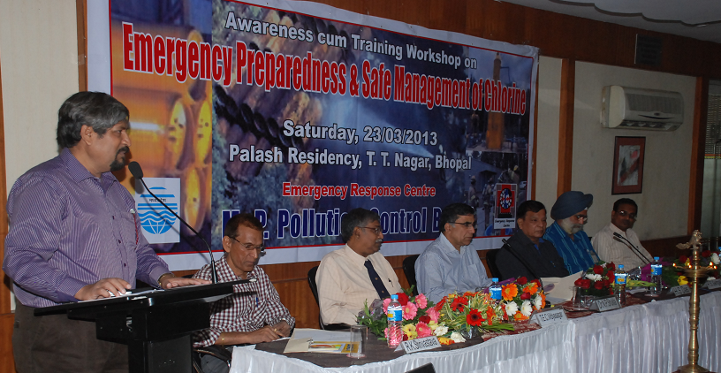
Well-come address and the Opening Remarks
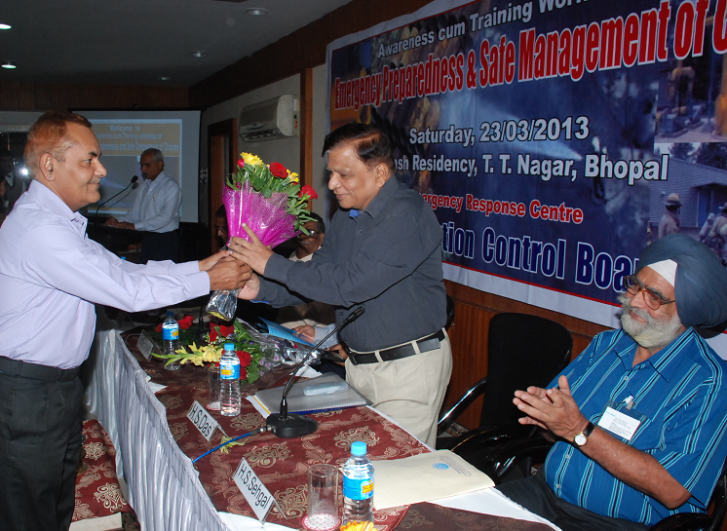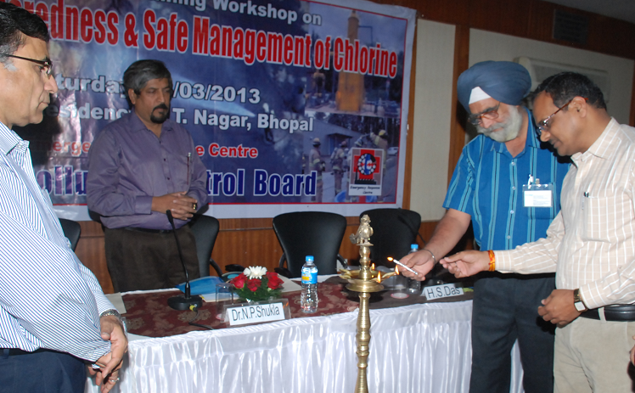
Floral Well-come and Lighting of the Ceremonial Lamp to Mark the Inauguration of Workshop
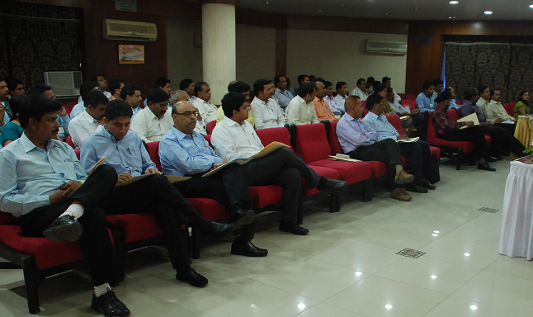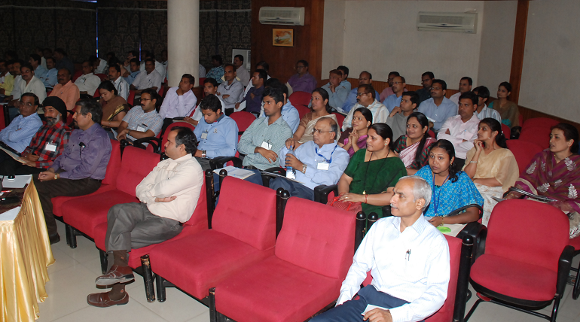
Audience engrossed in the deliberations during Technical sessions

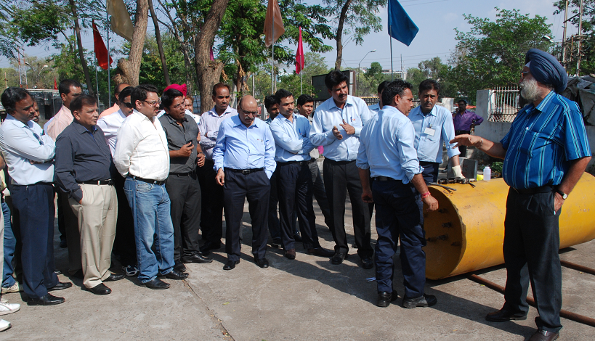
Chlorine leak detection & Control Procedure Demonstration on a Chlorine Tonner
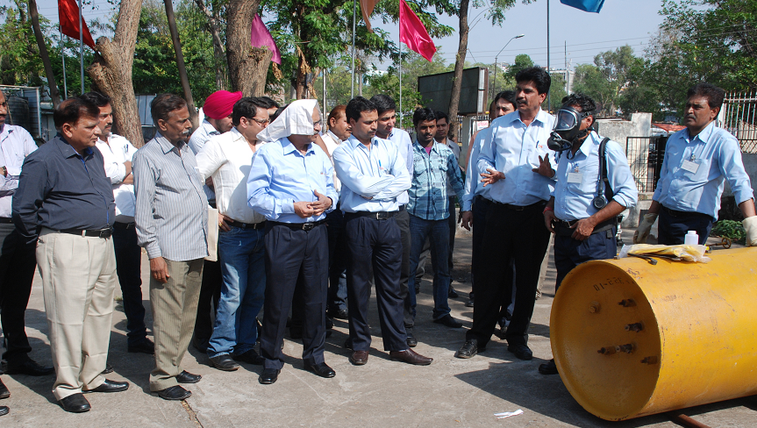

Demonstration of Personal Protection Equipment Use during chlorine leak & Containment

Awareness-cum-Training Workshop on
"Emergency Preparedness & Safe Management of Chlorine"

Saturday, 23rd March 2013

Venue - conference Hall, Hotel Palash Residency, Bhopal
Tentative Programme Schedule

9.15 - 10.00 am | Registration
10.00 - 11.00 am | Inaugural Session
10.00 - 10.20 am | Welcome adress/ Opening Remarks | Dr. Gunwant Joshi, ERC,M.P. Pollution Control Board, Bhopal  . " Role of Emergency Response Centre in Emergency Preparedness”
10.20 - 10.30 am | Address from guest of honour | Member Secretary/ State Disaster Management Authority
10.30 – 10.40 am | Address by Chief Guest | Shri Sanjay Shukla, IAS,
10.40-10.50 am | Address from the Chair | Dr. N.P. Shukla, Chairman, M. P. Pollution Control Board, Bhopal.
10.50 - 11.00 am | Vote of Thanks | Shri R.K. Shrivastava, S.E., MPPCB, Bhopal
11.00 - 11.20 am | …………………… Tea break ………………..
11.20 am – 12.50 pm  12.50 pm – 01.45 pm | Technical Session I & Discussion  1. "Safe Use of Chlorine & Emergency Preparedness in Water Works"  by Shri H.S. Das, Head, HSE, Alkali Manufacturers Association of India  2. "Safe Use, Handling and Transportation of Chlorine in Industry & Water works"  by Shri H.S. Sehgal, Ex DGM, M/s GACL, Vadodara
01.45 pm – 02.30 pm | ………………… Lunch Break …………………
02.30 pm – 04.00 pm  04.00 pm – 05.00 pm | Technical Session II & Discussion  1 . "Demonstration of Chlorine Safety: Leak detection & Management"  by M/s. Grasim Ltd. Nagada & Alkali Manufacturers Association of India  2." Safety & Preparedness : Concept of Table top Mock drills exercise"  by Shri TEC Vidyasagar, Ex.- Dy Chief Inspector of Factories, Govt of A.P.
05.00 – 05.30 pm | Panel Discussion followed by Feedback and Valediction

Organised by : Emergency Response Centre, M.P. P.C.B., Bhopal
Ph. : 0755-2469180, 2466191Fax : 075-2463742, E.mail - ercmppcb@nic.in, Web : www.ercmp.nic.in

