Awareness-cum Training Workshop on
On-site Emergency Planning, Preparedness & Response
Organized at Pithampur, Dist. Dhar on 14/09/2012 by
Regional Office, MPPCB Dhar & Emergency Response Centre

A Note on the Proceedings of the Workshop

The Regional Office, M.P. Pollution Control Board, Dhar organized a one-day awareness programme, in association with Directorate of Industrial Health & Safety, GoMP and Emergency Response Centre, Bhopal on 14th September 2012 at the Conference hall of M/s. Bridgestone India (Private) Ltd, Sector-III, Pithampur, Dist. Dhar. The activity was aimed to create awareness and capability among the industries to plan, prepare and test the on-site emergency plan. Considering the fact that the requirement of on-site emergency planning for industries is not merely a statutory requirement but it is a corporate and individual responsibility in national interest to plan out strategy in advance to meet any eventuality to avert or minimize the possible damage to the people and the environment. The workshop was solely focused on different aspects of on-site emergency planning and was coordinated by Emergency Response Centre, MPPCB Bhopal’.

The programme was formally inaugurated by Shri Sandeep Soni, S.D.M. district Dhar, and Shri P.D. Naria, Joint Director, Industrial Health & Safety, GoMP by lighting the ceremonial lamp. This was followed by the welcome address from Shri Hemant kumar Sharma, Regional Officer, M.P. Pollution Control Board, Dhar who, while welcoming the guests and the participants, briefly highlighted the issues related to the need of on-site emergency planning by industries in Pithampur and other industrial areas in the State. He also briefed about the aims and objectives of the workshop and hoped it to be in the benefit of all.

The chief guest of the function Shri Sandeep Soni, SDM, Dist. Dhar lauded the initiative taken by the MPPCB, Dhar and the Emergency Response Centre. He shared his experience and said that the emergency planning is required not only for industries or for those who are handling hazardous goods but is required by everybody in everyday life and one has to be prepared and tuned at all times to tackle the eventuality effectively. He highlighted the fact that negligence in tackling the on-site emergency can trigger into an off-site emergency causing more damage and, therefore, appropriate importance should be given to on-site planning. He was also of the opinion that similar workshop should also be organized for the other target players as well like district administration, police authorities, medical services, NGOs etc. on the off-site emergency planning.

He urged the need to take-up the issues of on-site emergency planning and preparedness not only with industries and the first responders but also with the people living in the vicinity because they are the people who would be affected first and at the same time they are the ones to provide first hand support in the event of an accident or an emergency. He also assured the industry participants to extend all possible support that could be given from administration side. He acknowledged the efforts of Shri Hemant Sharma, Regional officer Dhar and the ERC, M.P. Pollution Control Board, Bhopal in highlighting such an important issue and assured full support of administration for organizing such activities in future.

Shri Sanjay Sevekari, General Manager, M/s Bridgestone India (Private) Ltd welcomed the delegates and appreciated the efforts of M.P. Pollution Control Board for organizing such a useful programme of awareness creation among the industries personnel. He also pointed out that the emergency occurred in an industry can have its influence on the adjoining industries too and hence all the industries in a particular pocket should be made aware about the possible hazards of the adjoining industries. He emphasized the need to promote mutual aid in the event of chemical and other emergency situations. He also attracted attention of local administration and requested to step up the process to provide better infrastructure for transport and other amenities which are essentially required for smooth functioning of the industrial units. He thanked Shri Hemant Sharma, Regional Officer, MPPCB, Dhar and the ERC team for taking initiative in organizing such a useful activity.

Shri P.D. Naria, Joint director, DIHS welcomed the delegates and talked about the mandatory requirement of On-site emergency planning under Factories Act, Environment Protection Act etc. He urged the industries to comply the provisions of safety in the interest of industries and the nation as well because any kind of damage to the industry has a direct implications on the national economy. He appreciated the move taken by the MPPCB to invite the industries at one platform and provide them opportunity to interact with the experts in the field of emergency planning and industrial safety. He further expressed that such programs shall help develop better coordination amongst the industry, the first responders, regulators and the technical support group, such as ERC, and appealed the industry representatives to make best use of this opportunity.

The Vote of Thanks was extended by Shri D.K. Wagela, Scientist, Regional Office Dhar who appealed the audience to carry the massage of safe practices in the chemical process and requested the industries to adopt the safe practices in their own industrial installations by implementing the lessons of the workshop.

Nearly 150 participants from various industries, District administration, the first responders and the regulators (MPPCB and DIHS) attended the program.

The technical program was divided in to two technical sessions, the first comprising of four lectures and the second session comprising two deliberations followed by feed-back and query-response session.

The 1st technical session started with the deliberation by Dr. Gunwant Joshi who spoke on ‘Role of Emergency Response Centre’ and made aware the participants about the presence of this centre in Madhya Pradesh State. He presented the aims, objectives and various activities of ERC and elaborated on the capability and the strengths of ERC to disseminate the information as part of technical support to meet the chemical emergencies and like situations. He appealed the industries to make use of ERC facilities not only at the time of chemical emergencies but also to prepare and strengthen the capabilities by making & updating the on-site emergency plans and carrying out the mock drills, so that the accidents are tackled effectively before turning in to a disaster.

This was followed by deliberation by guest expert faculty Shri TEC Vidyasagar who first took up the topic on ‘Industrial Emergencies and their Consequences’. He illustrated various types of industrial emergencies which may occur during industrial operations and their consequences. He narrated examples of various emergencies in industrial sectors such as petrochemical plants, chemical industries, pharmaceutical units, textile establishments etc. His talk about ‘initiators of chemical accidents and emergencies’ was an interesting part of the presentation highlighting the causes that can trigger, and are responsible for causing, an emergency including natural calamities and sabotage activities. The formal techniques and quick methods of consequence analysis were also discussed during the course.

This was followed by technical presentation on ‘Planning, Preparedness and Response Process in Industrial Emergency Mitigation’. He detailed about various steps involved in planning for the emergency mitigation and the aspects that need to be touched upon to ensure preparedness for timely and effective response to meet out the crisis. Various mitigation tools and action plan to control and mitigate the emergencies were discussed by him during the talk. Toxic leak scenario, chemical transport emergency and other were also presented very effectively.

The next presentation of Shri Vidyasagar was focused on ‘Installation of on-site Emergency Response Plan’. He elaborated on statutory as well as corporate importance of on-site emergency plan (OSEP) and explained its various components which which need to be essentially considered while preparing the same. The process in preparing OSEP and its regular evaluation was also explained in detail. The requirement of emergency organization and shift emergency organization, key emergency personnel and their responsibilities during normal and emergency time etc were also part of deliberation.

The second technical session was more of interactive nature and the issues which were discussed included ‘designing and conducting mock-drill and approaches to design and conduct effective table-top exercise’. The importance of table-top exercise and mock-drill, and how it could be useful in preparing a sound on-site emergency plan, were discussed in detail. The participants also got to know the evaluation process of table-top exercise and mock-drill in order to further improve it. A proper and effective response during emergency can make a lot of difference and hence the participants were also taught about emergency response procedures during the session.

All the technical sessions were conducted by Dr. Rajendra Chaturvedi, Scientist, ERC, Bhopal. The programme was concluded with the distribution of the Certificates and thanks to the Chair, dignitaries and the participants.
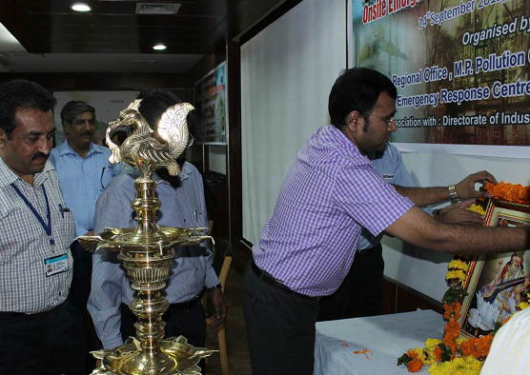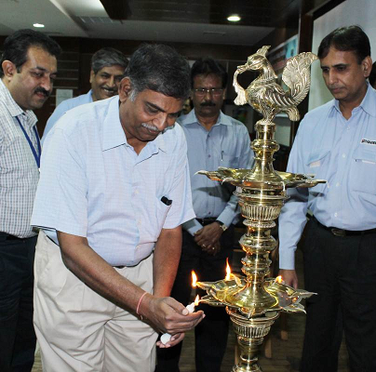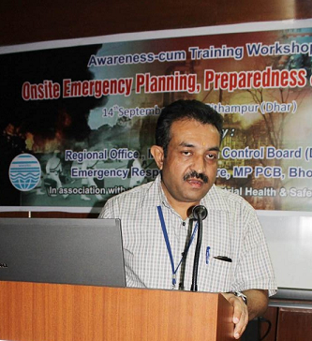
OPENING CEREMONY
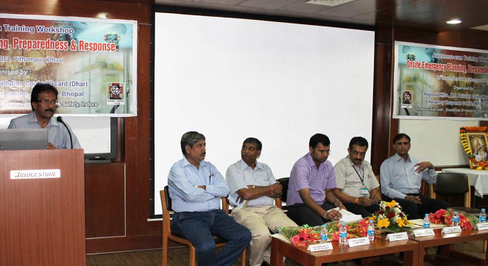

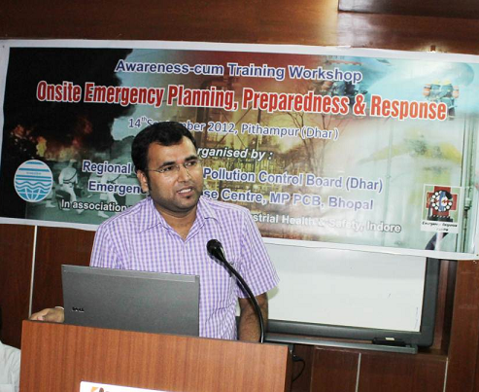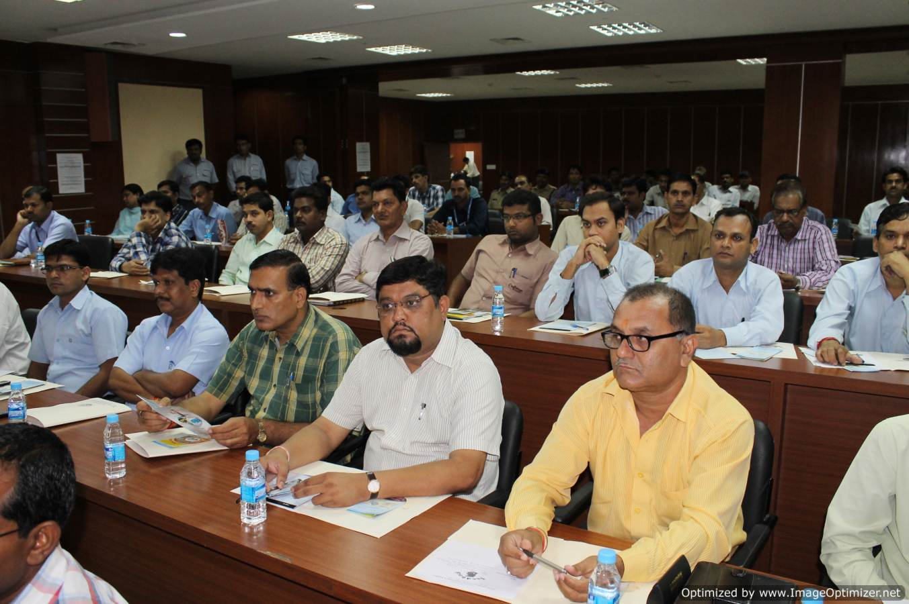

Inaugural speech by Chairman, Crisis Group Industry & First responder Participants
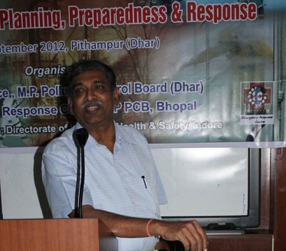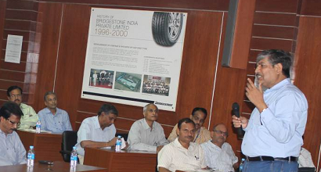
Expert Presentation
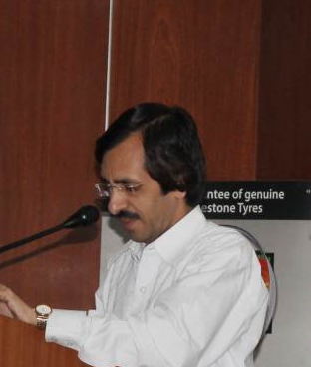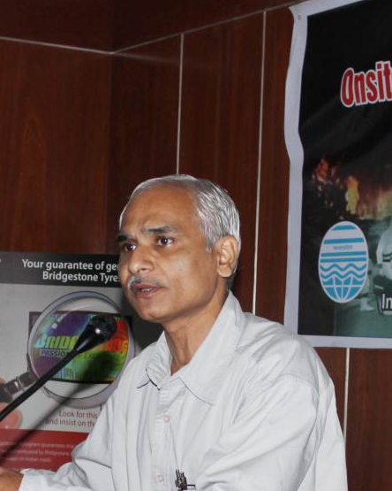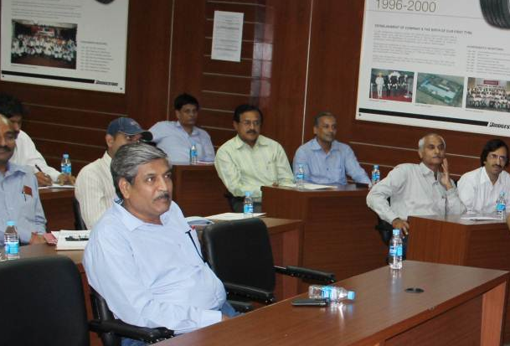

Technical Session in Progress



